**Walking Interviews**

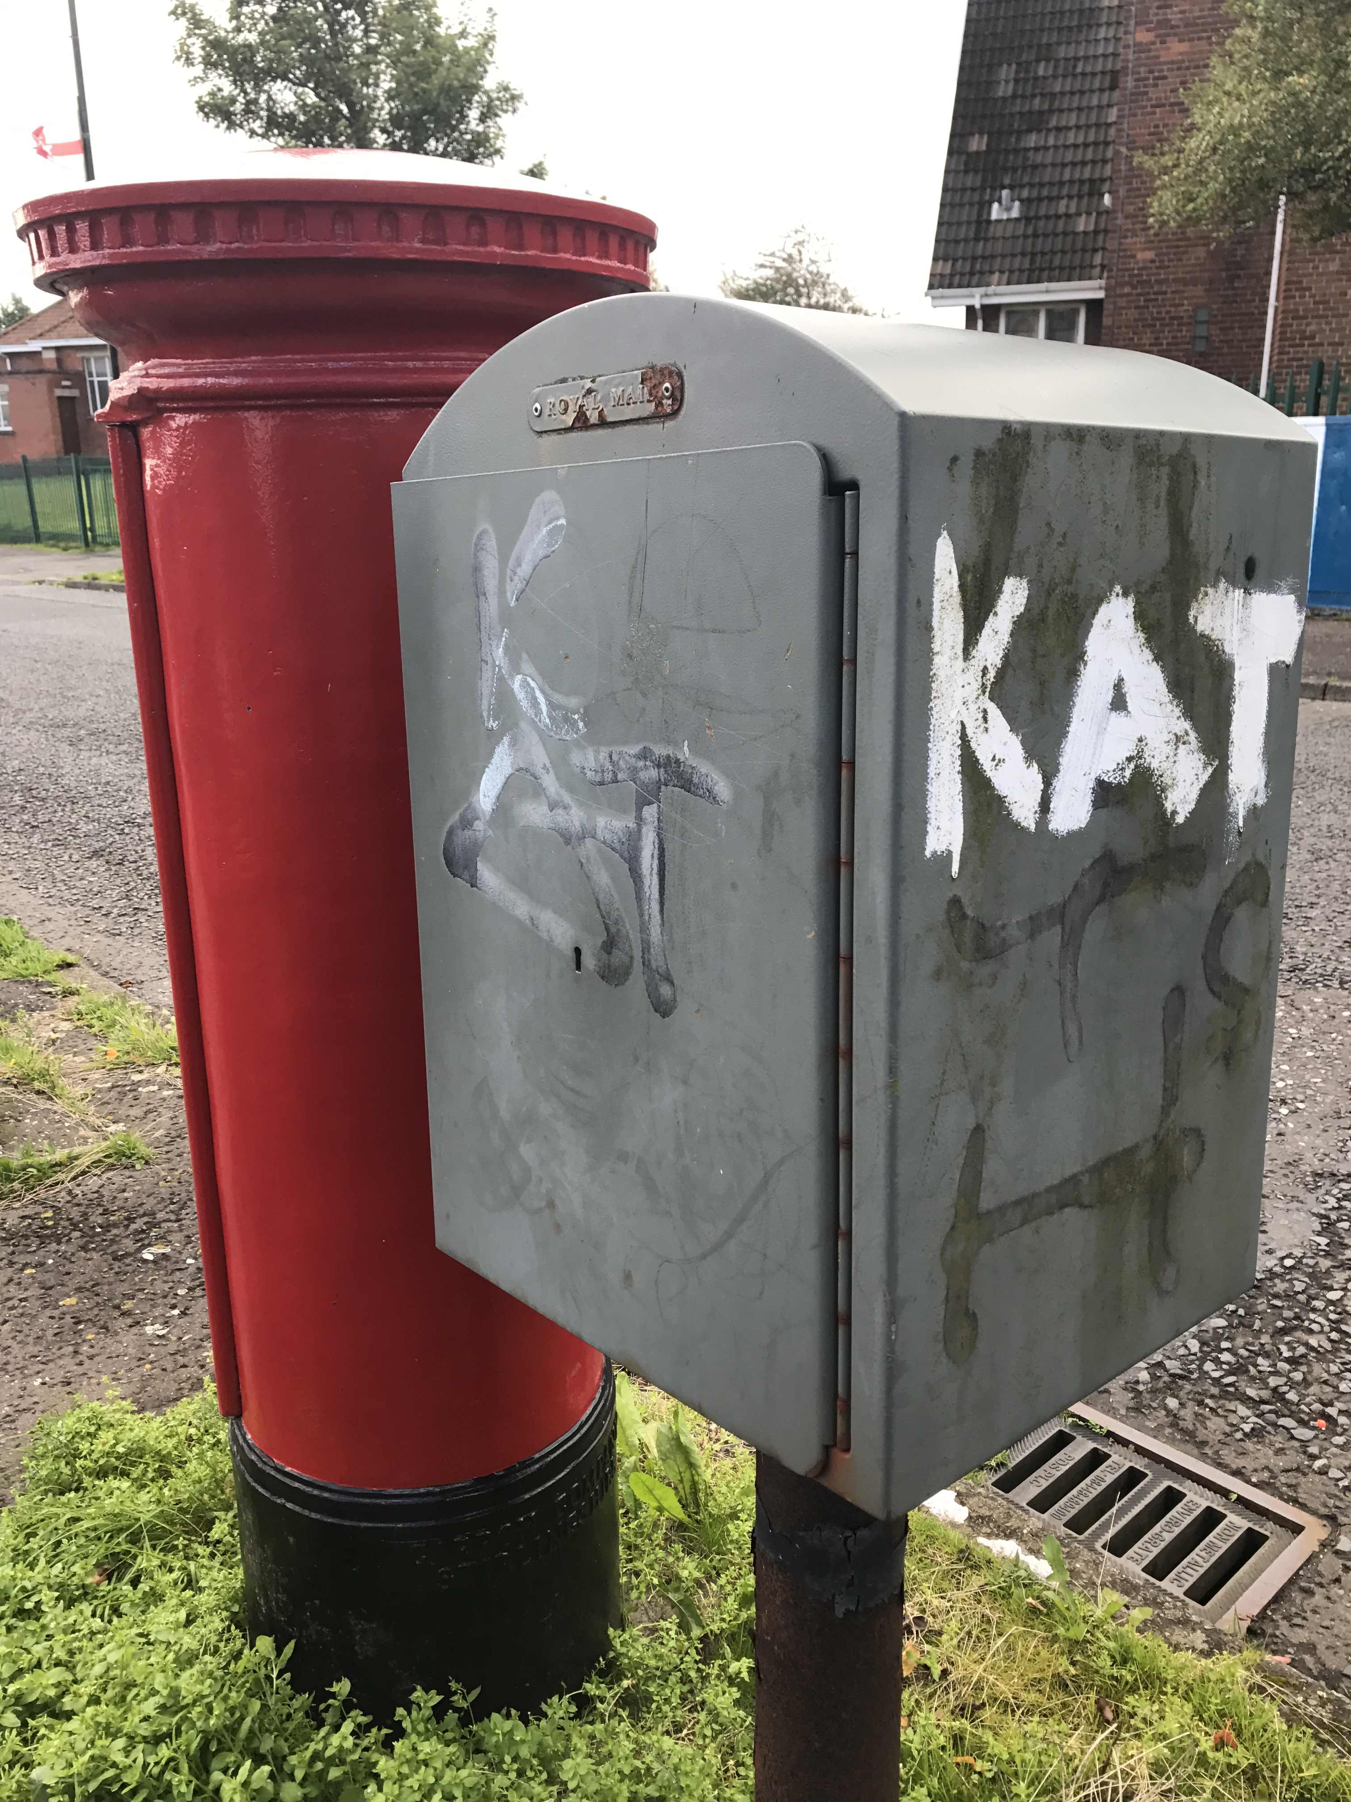Walking interviews, which probed a number of sociospatial factors shaping people’s mobility patterns, were a key methodological component of the Belfast Mobility Project. Based on the premise that ‘emplacing’ (Riley 2010) interviews in local landscapes can serve as vital ‘prompts’ (Evans and Jones 2011, 856) that reveal critical spatial knowledge and meanings, the project employed a modified version of Kusenbach’s (2003) ‘go-along’ method, in which the researcher accompanies a participant during their ordinary activities and routines. In this instance, the interviews comprised a flexible and open-ended sequence of questions asked ‘en route’ as the researcher and interviewee walked around the local area retracing a ‘typical’ journey for the participant. These interviews were audio-recorded and later transcribed. A second researcher photographed aspects of the landscape that featured prominently in the interviewee’s narrative, allowing images to be GPS/GIS linked to interview excerpts. The route of the walk was also tracked using the Belfast Pathways smartphone application described in the previous section.

Prior to leaving on the walk, each interviewee took part in a short indoor interview that focused on their personal background, social networks and ties to the local area. They were then given the following set of instructions:

*Imagine you are a tour guide and we are visiting your community. We want to get an idea of how you use and experience the local environment on a typical day. We are particularly interested in how living in a divided part of the city affects your everyday life.*

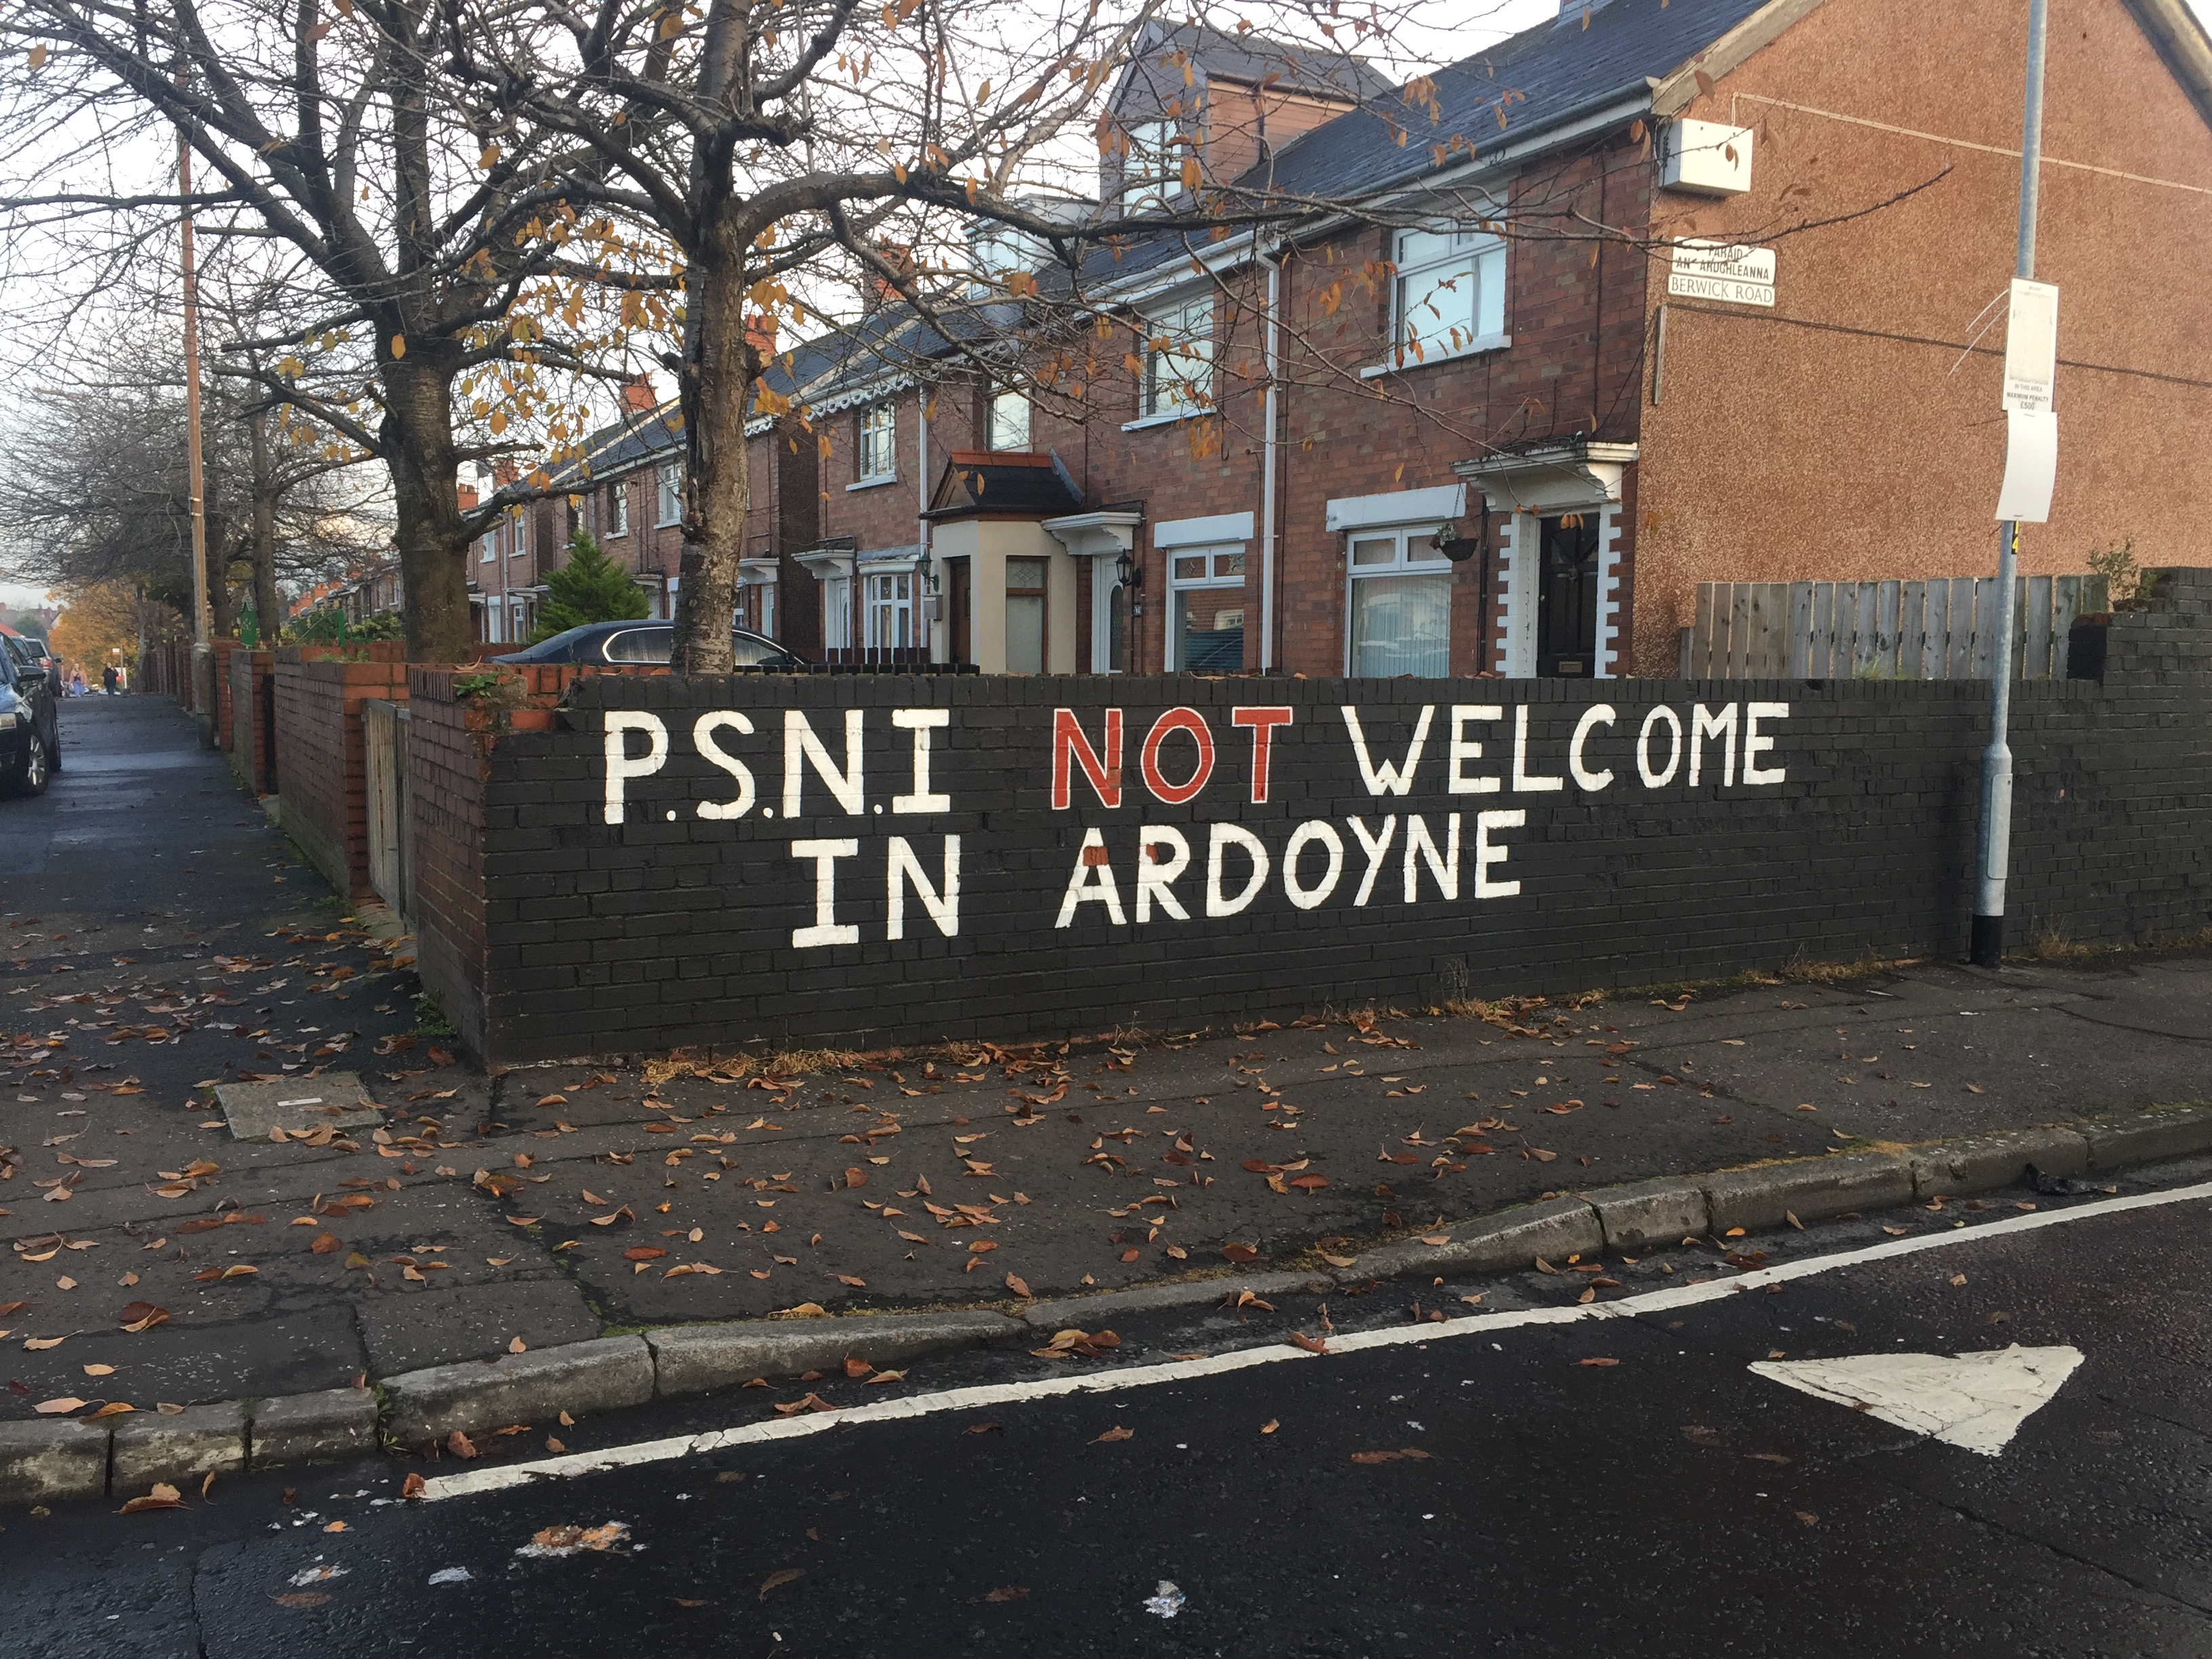

Throughout the walk, we sought to explore how different kinds of sectarian (and, in our instance, paramilitary) threat shaped how participants moved through and used the local environment. The goal was to gather as much concrete information as possible about how particular environmental features affected residents’ lived experience of using and moving through their local area. Thus, the interviewers took the opportunity to point out potentially relevant features that were present throughout the journey and explore how residents themselves felt about encountering these aspects en route. At the same time, they remained sensitive to more hidden or subtle landscape features that may have a meaning only for ‘insiders’ to the area.

We present below a sample interview schedule. The order and precise content of the questions varied across interviews, in response to the accounts provided by our participants during their actual walk. However, this schedule captures the core questions and themes that we addressed.

**Theme 1: Identity/Visual Markers/Affect**

* What does it feel like walking through this area?
* What features of the area make it feel safe? Unsafe?
* What landmarks do you identify with? What features of the environment make you feel uncomfortable?
* Are there changes that could be made to the local environment that would allow people to use the area more freely?

**Theme 2: Community**

* Tell us about the communities which live in close proximity to this area.
* Are there occasions when you have entered areas associated with the other community; if so, tell us about the circumstances? How could you tell you were in an area associated with that community? Did you feel safe?
* When walking around the local area, as we are now doing, do you generally worry about encountering or interacting with members of the other community? What about your own community?
* Are there times when you have altered your routes in order to avoid passing through or close to areas associated with the other community? If yes, tell or show us where this occurred. Do you ever change routes to avoid interacting with members of your own community?
* Are there any areas in your own community you wouldn’t enter? If so, why? Can you indicate any parts of the area that you would regard as equally ‘shared’ by both communities? Do you generally feel safe there? Do you use these kinds of mixed, shared spaces a lot?

**Theme 3: Facilities/Access**

* Are there local facilities that you would like to access more easily but are worried because they are located in or close to areas associated with the other community? Or are hard to physically access? Can you tell or show us where?
* How do you get to the city centre? How often do you go? Is it a safe and comfortable journey?
* If you had to give the government advice about how to make the local environment into a more open, inclusive space that could be shared by both communities, what would that advice be?